Professional development

My Aspirations

In the future I hope to develop my general skills in the cyber security field and computer science modules. As of right now I am not sure which specific part of the industry I wish to go further into after university however I hope after doing a placement year and in my other two years at University I will have the knowledge to do this. Mainly I hope to learn new programming languages as well as further my python knowledge, additionally I hope to improve my analysis and design skills plus networking. I intend to do this by carrying out small coding projects by myself over summer as well as taking part in online courses to further my skills and take them to the next level I will then improve on this in year 2 and 3 as well as my placement year which should grant me a lot of knowledge.

My current knowledge

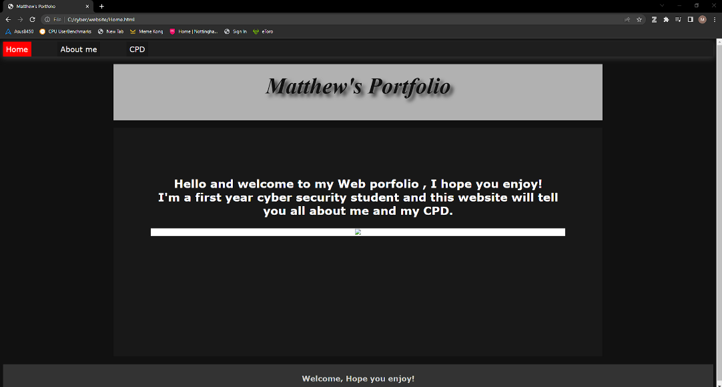As of right now I believe my strongest programming language is python this is because it is what we have been doing in lectures and labs as well as this most of my coursework has used this. I have also used html to design a website in term 1 which I consider quite successful. Furthermore, I thoroughly enjoyed my group coursework this term and it allowed me to function better in a team environment, from this I also learned about different methodologies and UI design as this is what I focused on.

Here is a small snippet of my code from my last piece of coursework as well as my home page for the website from term 1. To further these skills I will continue to do more python coding as well as work on my weaker areas. To achieve my objectives, I hope to learn more languages and new skills to do with cyber security.

Activities to improve(CPD)

I have attended many activities this week to improve my knowledge of placements including a 1-hour online lecture on placements as well as on Thursday the 27th I attended the 3-hour event about placements including a talk from people who had attended placements as well as got to talk to companies. This granted me lots of knowledge about placements and if I wanted to do one as well gave me an insight into job opportunities. I also watched the lecture about GitHub which showed me how important it was to use as a coder. Finally, I carried out 5 LinkedIn learning tasks about coding and computer science which helped me improve my basic skills and further them. I will complete more learning over the holidays to broaden and improve my skills like more LinkedIn learning and carrying out my own projects that will improve my programming skills. I also hope to carry out group work over the summer as two of my friends are also doing the same course this means we can work together and help improve each other as well as carry out projects. Furthermore, over the summer I hope to carry out some unpaid work at one of my family friend’s cyber security businesses this will grant me work experience in the field and develop both my programming and group work as it is a small business but also allow me to experience first hand what working in the industry is like. Finally, I attended many guest lectures from various speakers this term this granted me a greater insight into companies what their roles were, it also enabled me to think about my future and the role I want.

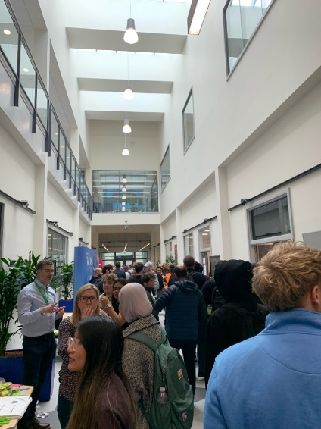Ethical and Professional Conduct

Picture taken by me in istec with companies.

During the CPD activities I maintained a professional conduct – during the talk with past students about placements I did this by not speaking to interrupt them listening to what they had to say and been thoughtful, I also maintained this after asking questions to the companies in the Istec building and listening to what information they had. I also carried this out by making notes from the online guest, GitHub and placement lectures – during these I also discussed the point that were brought up with my flatmate who is on my course this enabled us to help each other and explain what we didn’t understand. During my studies I maintained a good conduct my attending labs and lectures and asking questions in these when I was stuck, I also working in small group outside of the labs where we helped each other. To improve this term, I could have attended more lectures as I was mostly going to labs as I found these a lot more beneficial to grow my skills and improve, therefore next year I will increase my attendance in all modules lectures instead of going over the slides, this should help me with anything I become stuck on as it will be explained more clearly. Finally, I maintained this professional conduct by treating everyone equally by communicating openly and honestly as well as building friendships with my peers.